CIRCUIT ANALYSIS LAB_5
Name: Muhammad Uzair
Reg No: 2025-CE-112
Date: 31stMarch,2026

Experiment # 1:
Circuit Made In Proteus:
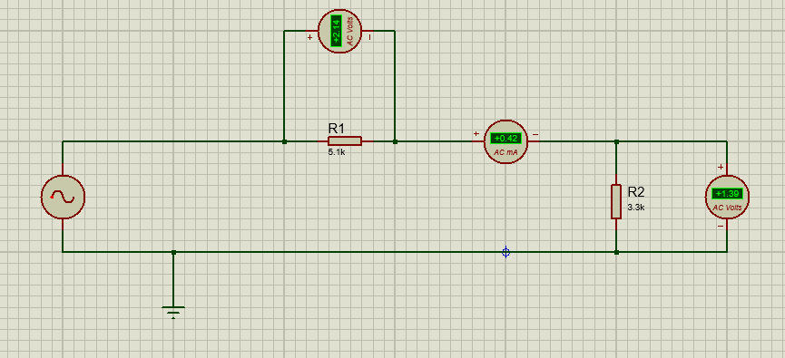
Construction:
- Insert Two Resistors R1 and R2 of 5.1kΩ and 3.3kΩ resistances respectively.
- Insert Alternator from Instruments section.
- Connect Alternator with R1.
- Connect R1 with R2 in series and also connect AC Ammeter in series between the Resistors.
- Connect R2 with Alternator and also insert Ground wire in between Alternator and R2.
- Set Alternator to Amplitude = 5V and Frequency = 50Hz.
- Connect two AC Voltmeter in parallel with R1 and R2 respectively.
- Change the range of ammeter from Amperes to Mili-Amperes.
- The Circuit According to the requirements is completed. Run it and Observe.

Experiment # 2:
Circuit Made In Proteus:
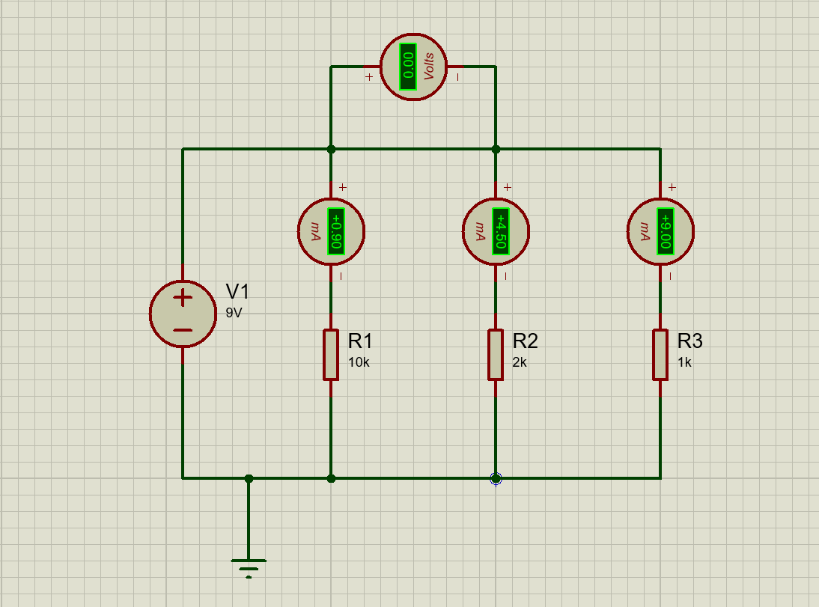
Construction:
- Insert Three Resistors R1, R2 and R3 of 10kΩ, 2 kΩ and 1kΩ resistances respectively.
- Insert DC Voltage Source and Set it to 9V.
- Connect R1, R2 and R3 in parallel with each other.
- Connect terminals of source with both ends of the parallel combination (positive terminal to the top rail, negative terminal to the ground/bottom rail).
- Connect DC Ammeters in series with R1, R2 and R3 for Current measurements across each resistor.
- Connect DC Voltmeter directly with R1 and R2.
- The Circuit According to the requirements is completed. Run it and Observe.

